Listening Center: Describing People

Select your level of challenge (Tier A, B, or C). Watch the music video “Somos Uno” and complete a tiered cloze activity you chose:

https://www.youtube.com/watch?v=eNFRDs5kqvo

Check your answers.

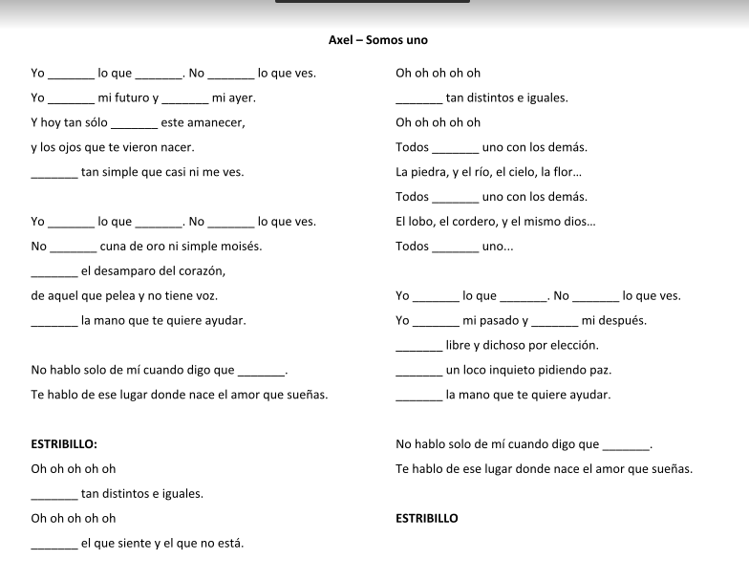
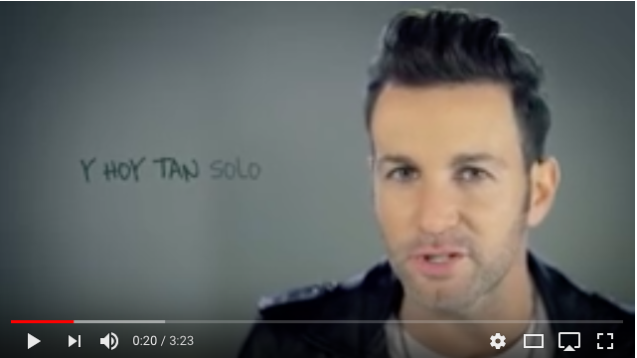

As an extension activity, create a new verse of the song using the song as a model.

