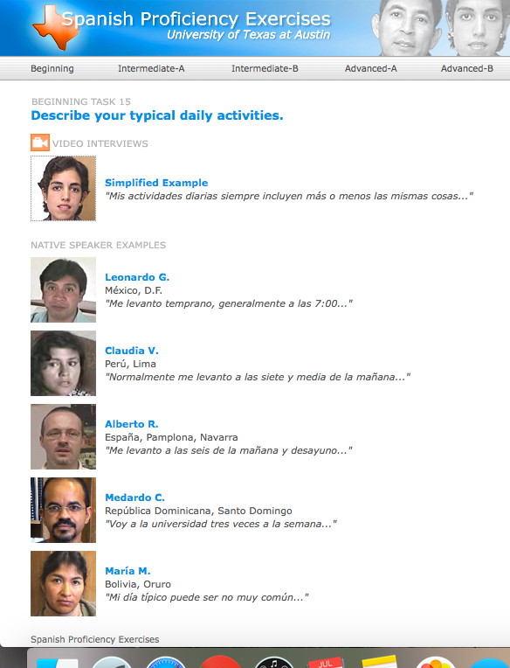

**Listening Station: Daily Routine**

Select one person and record the information they give about their daily routine.

<https://www.laits.utexas.edu/spe/beg15.html>