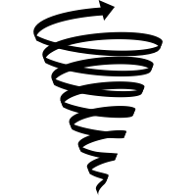

**Spiraling Questions**

**What do you think?**

**How do you know?**

**What else?**

**What is an example?**

**Why? How?**

**Who? What? When? Where?**

**Is it this or that?**

**Yes/No, Either/Or**

**Spiraling Questions**

**Spiraling Questions**

**Yes/No, Either/Or**

**Is it this or that?**

**Who? What? When? Where?**

**Why? How?**

**What do you think?**

**How do you know?**

**What else?**

**What is an example?**

**What do you think?**

**How do you know?**

**What else?**

**What is an example?**

**Why? How?**

**Who? What? When? Where?**

**Is it this or that?**

**Yes/No, Either/Or**