Reading Center: Describing People

Read the transcript to the commercial, “Sin gol, no hay fútbol.” List opposites you find in the transcript. At the end, tell what you think the commercial is about using your own words.
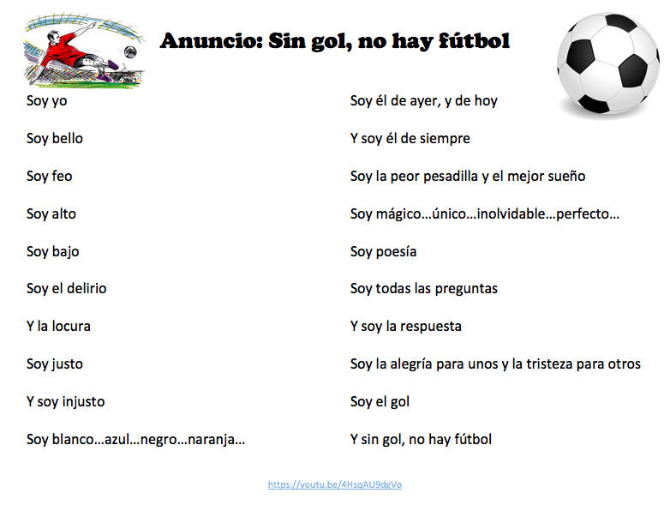

If you finish before time is called, watch the video: https://www.youtube.com/watch?v=ruxatNHUgwE

