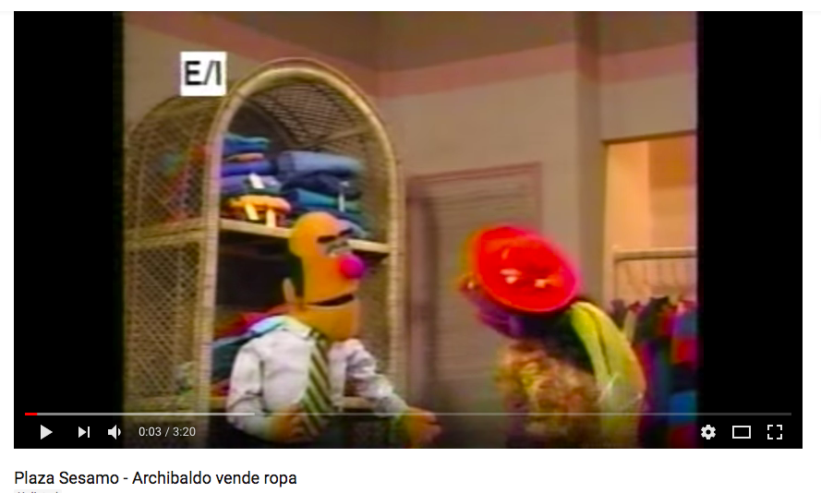

<https://www.youtube.com/watch?v=hLjk6YY09BA>

**Listening/Viewing Station: Clothing**

**Archibaldo vende ropa**

Select the tiered listening activity (A, B, or C ) based on your readiness level. Watch the video and complete the activity page.